|  |  |
| --- | --- |
| Ubuntu Artisans Collective  Part:2 | NTHANGENE NDLOVU |

Contents

Project Overview 2

Website Goals and Objectives 3

Improvements from Part 1 3

Refinements (Part 2) 4

Changelog 4

Version 1.0 (Part 1) 4

Version 2.0 (Part 2) 4

File Structure 5

GitHub Repository 6

Responsiveness Testing 6

License 6

Ubuntu Artisans Collective Website

# Project Overview

The Ubuntu Artisans Collective website is a responsive e-commerce platform for a Johannesburg-based cooperative of 50 local artisans. It showcases products, tells artisan stories, and provides a platform for online sales while promoting African craftsmanship traditions.

**Student Information**

* **Student Name:** Nthangene Ndlovu
* **Student Number:** 10492130
* **Course:** WEDE5020
* **Institution:** The Independent Institute of Education
* **Date:** 27 September 2025

# Website Goals and Objectives

1. Increase average order value through upselling and bundling.
2. Cultivate brand loyalty via the “Artisan Insider” loyalty program.
3. Expand international sales into key markets (UK, US, Germany).
4. Reduce cart abandonment by implementing recovery strategies.
5. Strengthen artisan storytelling and engagement.

# Improvements from Part 1

* Fixed inconsistent font usage across pages → standardized with **Google Fonts (Playfair Display & Lato)**.
* Improved **mobile responsiveness** using media queries for tablet and phone layouts.
* Enhanced **navigation bar** with hover effects and consistent styling across all pages.
* Corrected **semantic HTML structure** for accessibility (proper <header>, <main>, <footer> usage).
* Optimized images and updated alt attributes for accessibility.

# Refinements (Part 2)

* Applied **Flexbox and Grid** for structured layouts across all pages.
* Added **consistent color palette** (earthy tones: browns, beige, green accents).
* Improved **form styling** on Contact and Enquiries pages (labels, inputs, buttons).
* Updated spacing, padding, and margins for a clean, modern layout.
* Introduced **responsive image scaling** (max-width: 100%) to prevent overflow.
* Made navigation sticky on desktop for easier browsing.

# Changelog

## Version 1.0 (Part 1)

* Initial HTML structure created for all main pages.
* Basic navigation system added.
* Content integration for homepage, about, artisans, and products.
* Images optimized and file structure organized.
* Basic responsive design added.

## Version 2.0 (Part 2)

* Implemented **external stylesheet (style.css)** linked to all pages.
* Applied **desktop-first styling** with responsive breakpoints for tablet and mobile.
* Consistent typography and color scheme introduced.
* Improved **forms** (Contact & Enquiries).
* Navigation refined with hover/active states.
* README.md updated with improvements, refinements, changelog, and references.

# 

# File Structure

Ubuntu_Artisans_Website/

│── index.html

│── about.html

│── contact.html

│── enquiries.html

│── services.html

│── README.md

│

├── css/

│ └── style.css

│

├── js/

│ └── script.js

│

├── images/

│ ├── artisans/

│ │ ├── lindiwe.jpg

│ │ ├── thomas-moloi.jpg

│ │ └── nomsa-dlamini.jpg

│ ├── products/

│ │ ├── zulu-basket-01.jpg

│ │ ├── beaded-necklace-01.jpg

│ │ └── ceramic-pot-01.jpg

│ ├── workshops/

│ └── logo.png

# Screenshots of responsive layouts

Mobile Screenshot

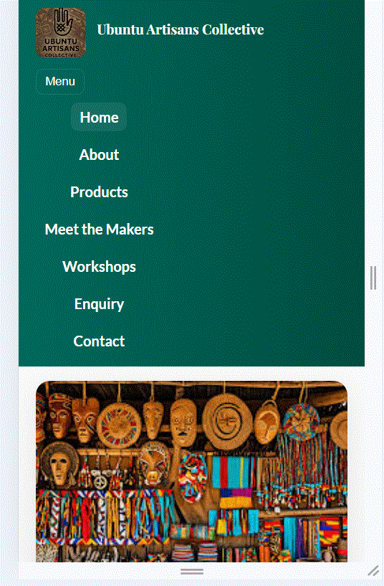

## Desktop Screenshot

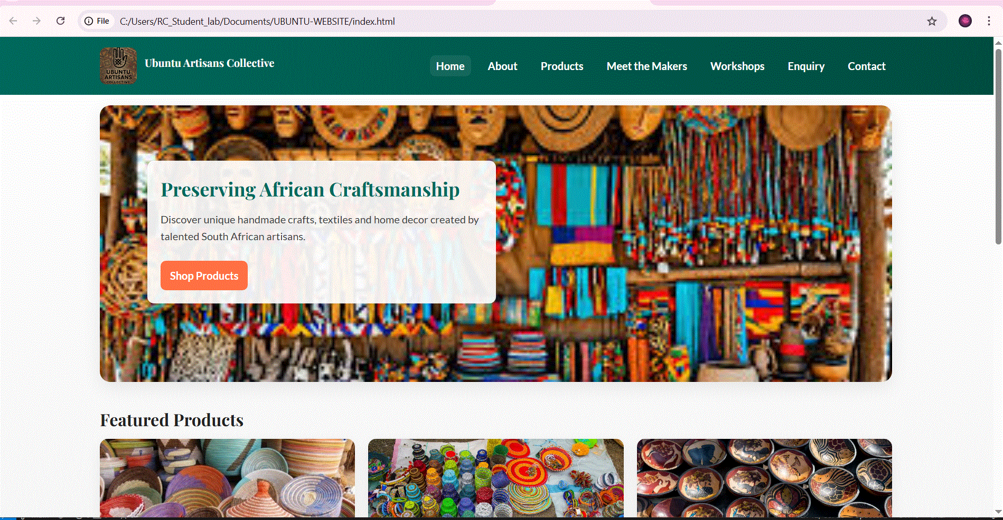

# GitHub Repository

[Ubuntu Artisans Collective Website Repo](https://github.com/Nthangi/Ubuntu-Artisans-Collective-Website)

# Responsiveness Testing

The website was tested using:

* **Google Chrome DevTools** (mobile & tablet simulation).
* Screen widths: **375px (mobile)**, **768px (tablet)**, **1024px+ (desktop)**.
* Screenshots of responsive layouts included in repository.

# License

This project is for educational purposes as part of The Independent Institute of Education coursework.

References

* Binns, T., Dixon, A. and Nel, E. (2018) *People and environment in Africa*. 3rd edn. London: Routledge.
* Department of Trade, Industry and Competition (2021) *South African creative industry growth report*. [PDF] Pretoria: Government of South Africa. Available at: <<https://www.thedtic.gov.za> >[Accessed: 17 August 2025].
* Liedeman, R. (2020) ‘The informal economy and township markets in South Africa’, *Journal of Southern African Studies*, 46(5), pp. 933-950.
* McCormick, D. (2019) *Artisans and micro-enterprises in African economies*. African Studies Review, 62(3), pp.65–87.
* PwC South Africa (2022) *The rise of e-commerce in South Africa*. [online] Johannesburg: PricewaterhouseCoopers. Available at:< <https://www.pwc.co.za> >[Accessed: 17 August 2025].
* South African Tourism (2021) *Annual tourism report 2020/21*. [pdf] Johannesburg: South African Tourism Board. Available at: <<https://www.southafrica.net/research/en/reports/tourism-performance> >[Accessed: 17 August 2025].
* Unsplash (2023) *Free images & pictures*. Available at:< <https://unsplash.com/> >[Accessed: 17 August 2025].
* Pexels (2023) *Free stock photos*. Available at: < <https://www.pexels.com/> >[Accessed: 17 August 2025].